

hDVR System Manager User Manual

Contents
1 hDSM Overview 4
2 Connect with hDVR 4
3 hDSM Operation 6
3-1 Check the Status of the hDVR Engine 6
3-2 Start the hDVR Engine 8
3-3 Stop the hDVR Engine 9
3-4 Restart the hDVR Engine 12
4 Configure the Software 13
4-1 Backup Current Configurations 13
4-2 Restore Configurations 16
5 Working with Storage Management 18
5-1 Detect Available Disk Volume(s) 18
5-2 Analyze storage blocks 20
5-3 Add storage repository to the system 22
5-4 Remove storage repository from the system 24
5-5 Format system hard disk 27
5-6 Reset System Partition 29
6 Collect hDVR Logs 31
7 System Diagnostic 33
7-1 Compression Card Tests 33
7-2 Audio Test 35
7-3 Test Database 37
8 LCM 39
8-1 Start LCM 39
8-2 LCM Operation 40
9 System Configuration 41
9-1 Network settings 41
9-1-1 IP Configuration 41
9-1-2 DNS Configuration 45
9-2 File sharing 53
9-2-1 Enable File sharing 53
9-2-2 Access hDVR Shared Folder 54
9-2-3 Disable File sharing 56
9-3 Date/Time change 59
9-4 Time zone change 62
9-5 NTP Management 64
9-5-1 Add NTP Server 64
9-5-2 Remove NTP Server 67
9-5-3 List NTP Server(s) 69
9-5-4 Start NTP Server 72
9-5-5 Stop NTP Server 74
9-5-6 Restart NTP Server 75
9-5-7 Enable hDVR as NTP Server 78
9-5-8 Disable hDVR as NTP Server 80
9-6 hDSM Language Setting 81
10 System Operation 83
10-1 Reboot hDVR System 83
10-2 Shutdown hDVR System 86
10-3 Enable hardware watchdog 88
10-4 Disable hardware watchdog 90
11 System Recovery 92
11-1 Reset to System Default 92
11-1-1 Reset Database to Default 92
11-1-2 Reset Configuration to Default 95
11-1-3 Reset Both Database and Configuration to Default 98
11-2 Restore from Backup 102
11-2-1 Restore Database from Backup 102
11-2-2 Restore Configuration 106
11-2-3 Restore Both Database and Configuration from Backup 110
11-3 Rebuild Video Data Index in Database 113
11-4 Reclaim Video Storage Slots 116
11-5 Reset Administrator Password 119

hDSM Overview
The hDVR System Manager (hDSM) is a Linux-based application used for advanced video recorder configuration. All MatriVideo video recorders run on an embedded Linux operating system. Embedded Linux provides a number of advantages over the Windows platform. It is more stable, requires fewer system resources, is less susceptible to viruses, and is easier to troubleshoot. Because the operating system is stored on a compact flash card, hard drive failure will never result in operating system failure. If there is ever a problem with the operating system, replacement of the compact flash card is quick and easy. This manual provides instructions on how to complete all system configuration tasks using the hDSM.

Connect with hDVR
- Open Putty. Putty is installed automatically along with all versions of the Command Center series software.

- Input the IP Address of the desired video recorder and click Open.

- Input the username and password and press <Enter> to login. The default username is root and the default password is id.

Note: To change the default password type passwd at the Linux prompt and press <Enter>. Type the new password and press <Enter>. Retype the password to confirm the change and press <Enter> again.

- Input hdsm and press <Enter>.

The hDSM is a menu-driven program. Use the arrow keys to move the cursor through the function list. Press <Enter> to execute the currently selected command.

To exit the hDSM, move the cursor to ‘Cancel’ and press <Enter>.

Note: The numeric keys can be used to instantly move the cursor to the corresponding function.

Note: It is also possible to connect to the hDVR by plugging a keyboard and monitor directly into the machine.

hDSM Operation

Check the Status of the hDVR Engine

- On the main menu, select ‘hDVR.’

- Select ‘Status.’

- The system displays the status of the hDVR.

Start the hDVR Engine

- On the main menu, select ‘hDVR.’

- Select ‘Start.’ The hDSM will activate the hDVR.

Note: The hDSM will enable hardware watchdog automatically after starting the hDVR.

Stop the hDVR Engine

- On the main menu, select ‘hDVR.’

- Select ‘Stop.’ The hDSM will deactivate the hDVR engine.

Note: Disable hardware watchdog to avoid system reboot while the hDVR engine is deactivated.

Restart the hDVR Engine

- On the main menu, select ‘hDVR.’

- Select ‘Restart.’ The hDSM will restart the hDVR engine.

Configure the Software

Backup Current Configurations
This function allows the user to back up the current configuration (camera name, recording schedule, etc.).

- On the main menu, select ‘Backup/Restore Configuration.’

- Select ‘Backup current configuration.’

- The system will ask for confirmation to stop the hDVR process.

- Input a name for the backup file. If no name is given the system will save the file using the default name (backup).

- When the message ‘hDVR backup completed’ appears, press <Enter> to return to the main menu.

Restore Configurations
This function allows the user to restore a previous configuration (camera name, recording schedule, etc.) from a backup.

- On the main menu, select ‘Backup/Restore Configuration.’

- Select ‘Restore configuration.’

- Input the name of the backup file and press <Enter>.

- When the message ‘hDVR config restore completed’ appears, press <Enter>.
Note: Restart the hDVR to activate the restored configuration.

Working with Storage Management
The storage management function allows the user to view and change the status of storage repositories in the hDVR. Disable hardware watchdog and stop the hDVR engine before executing these functions.

Detect Available Disk Volume(s)
This function allows the user to view the status of all storage repositories in the hDVR.

- From the main menu, select ‘Storage Management.’

- Select ‘Detect available disk volume(s).’

- The system shows the hard disk list. The list contains 6 parameters:
- HDD – The name of the detected hard drive.
- Type – The hard drive type.
- Size – The size of the hard drive.
- Status – The running status of the hard drive (NA/ InUse/ NotInUse).
- Blocks in HDD – The number of blocks in the hard drive.
- Blocks in DB – The number of blocks in the database associated with the drive.

Analyze storage blocks
This function calculates the number of bad blocks on all available hard drives.

- On the main menu, select ‘Storage Management.’

- Select ‘Analyze storage blocks.’

- The following information is displayed:

- Storage ID – The storage ID of the disk.
- Device Name – The name assigned to the disk by the system.
- Blocks in DB – The total number of blocks in the database.
- Bad Blocks – The number of bad blocks on the disk.

Add storage repository to the system
Note: Physically install all hard drives in hDVR before executing this function.

- From the main menu, select ‘Storage Management.’

- Select ‘Add storage repository.’

- Select the destination hard disk from the list and press <Enter>.

Note: Before adding a RAID-5 drive the RAID array must be created. Refer to the RAID manual for instructions related to creating a RAID array.

- When the process is completed the system will display the message: ‘Storage ID xx has been added to the system.’ (xx indicates the ID number)

- Repeat Step 3-4 for any additional storage repositories.

Note: hDVRs with a SATA interface only support SATA2. Before installing a SATA hard drive the hardware settings of the hard drive must be configured for SATA2.

Remove storage repository from the system
This function will remove storage repositories from the system.

- From the main menu, select ‘Storage Management.’

- Select ‘Remove storage repository.’

- Select the target hard drive from the list and press <Enter>.

- The system will ask for confirmation of the operation.

- The message ‘XXX was successfully removed from the system’ will appear upon completion of the operation.

Format system hard disk
This option will reformat the entire system drive. All video data will be erased.

- From the main menu, select ‘Storage Management.’

- Select ‘Format system hard disk.’

- The system will ask for confirmation to stop the hDVR.

- The system will display a message confirming that the operation has completed successfully.

Reset System Partition
This option will reset the system partition. The data partition will be unaffected.

- From the main menu, select ‘Storage Management.’

- Select ‘Reset system partition.’

- The system will ask for confirmation to stop the hDVR.

- The system will display a message confirming that the operation has completed successfully.

Collect hDVR Logs
hDVR logs contain detailed information regarding the hDVR system and can serve as diagnostic reports should there be a problem with the hDVR. To collect hDVR logs, follow the steps below:

- From the main menu, select ‘Collect hDVR Logs.’

- Input a file name. If no file name is entered the system will save the file as ‘log.’

- The system will confirm the operation. The log five will be saved at /Share/XXXX.tar.gz.’

Note: See section ‘File sharing’ for instructions on how to access the log files using Windows Explorer.

System Diagnostic
The system diagnostic function provides three tools for testing hDVR hardware and software. Before running any diagnostic tests, hardware watchdog must first be disabled and the hDVR engine stopped.

Compression Card Tests

- From the main menu, select ‘System Diagnostic.’

- Select ‘Compress Card Tests.’

- The system will display the result of the test.

Note: The hDVR must be restarted manually upon completion of diagnostic tests.

Audio Test
- On the main menu, select ‘System Diagnostic.’

- Select ‘Audio Test.’

- The system will play music for a period of 30 seconds during which the user can verify that the hDVR audio output is functioning properly.

Test Database

- From the main menu, select ‘System Diagnostic.’

- Select ‘Database Tests.’

- The system will display the test result upon completion.

LCM
LCM is a stand-alone program that allows the hDVR to function as a single monitoring server by connecting a monitor, keyboard, and mouse.

Start LCM
Follow these steps to run LCM:

- From the main menu, select ‘LCM.’

- Select ‘Start LCM.’

- Physically connect a monitor, keyboard, and mouse to the hDVR.

LCM Operation

- The monitor shows the images from the cameras.
- ↑ or ↓: specify to change the display layout. There are four default layouts: 1×1, 2×2, 3×3, and 4×4.← or →: specify to switch the camera source in the 1×1 layout.
- <T> or Space: to trigger the Tour function. The LCM displays all images from the first camera to the last camera. In 1×1 layout, the LCM displays the image of Camera 1. In 2×2, the LCM displays the images of Camera 1-4, and vice versa.
- Esc: to exit the LCM.

System Configuration
The system configuration function allows the user to change hDVR system settings.

Network settings
The ‘Network setting’ function allows the user to change two types of configuration – IP and DNS.

IP Configuration

- From the main menu, select ‘System Configuration.’

- Select ‘Network settings.’

- Select ‘IP Configuration.’

- Select ‘eth0.’

- Select ‘Enable eth0.’

- Select ‘Static IP Configuration.’

- Input a new IP address and Netmask for the hDVR. Leave the default gateway blank if there is no gateway active on the network.

- Select <Yes> to save the new configuration.

- Run the saveconfig command at the Linux command prompt. The modified values will be saved to the CF card (system disk).

Note: The saveconfig command forces the system to save the new configuration in the CF card which prevents the new configuration from being lost in the event of unexpected shutdown or rebooting

Note: Keep the value of MTU as default (1500) unless you have other devices such as a SAN connected to the same network

DNS Configuration
The ‘DNS configuration’ function has three subsidiary functions – ‘Show DNS Server,’ ‘Add DNS Server,’ and ‘Remove DNS Server.’

Show DNS Server

- From the main menu, select ‘System Configuration.’

- Select ‘Network settings.’

- Select ‘DNS Configuration.’

- Select ‘Show DNS Server.’
- The system will display the DNS server for the hDVR.

Add DNS Server

- From the main menu, select ‘System Configuration.’

- Select ‘Network settings.’

- Select ‘DNS Configuration.’

- Select ‘Add DNS Server.’

- Input the IP address of the new DNS server.

- Run the saveconfig command at the Linux prompt. The modified values will be saved to the CF card (the system disk).

Remove DNS Server

- From the main menu, select ‘System Configuration.’

- Select ‘Network settings.’

- Select ‘DNS Configuration.’

- Select ‘Remove DNS Server.’
- Select DNS server to be removed.

- Run the saveconfig command at the Linux prompt. The modified values will be saved to the CF card (the system disk).

File sharing
The ‘File Sharing’ function allows the user to access the hDVR shared folder from another computer using Windows Explorer.

Enable File sharing

- From the main menu, select ‘System Configuration.’

- Select ‘File sharing.’

- Select ‘Enable File sharing.

Access hDVR Shared Folder
hDVR log files are saved in the ‘Shared’ folder on the hDVR. Follow these steps to access the ‘Shared’ folder.

- On your Windows PC, go to Start → Run and type in the IP address of the hDVR. Click OK to continue. Or, alternatively, open Windows Explorer and type in the IP address of the hDVR.

- There will be a directory named ‘Share.’ The log file will be saved inside as a zipped file with the name assignment chosen when the log was created.

Disable File sharing

- From the main menu, select ‘System Configuration.’

- Select ‘File sharing.’

- Select ‘Disable File sharing.’

Note: For better security, it is recommended that the file sharing function be disabled after use.

Date/Time change

- From the main menu, select ‘System Configuration.’

- Select ‘Date/Time change.’

- The system will ask for confirmation to stop hDVR processes before continuing.

- Select the appropriate day, month, and year. Select ‘OK’ when finished.

- Input the appropriate time. Select ‘OK’ when finished.

- Select ‘Proceed’ to confirm the change.
Note: The hDVR must be restarted to activate the new settings.

Time zone change

- From the main menu, select ‘System Configuration.’

- Select ‘Time zone change.’

- Select the continent, country, and region.

- The system will display the new time zone settings and ask to confirm the change.
- Run the saveconfig command at the Linux prompt. The modified values will be saved to the CF card (the system disk).

Note: Restart the hDVR to activate the new settings after completion.

NTP Management
NTP Management allows the user to select a time server with which to synchronize the hDVR. The time server may be another hDVR or an external web server.

Add NTP Server

- From the main menu, select ‘System Configuration.’

- Select ‘NTP Management.’

- Select ‘Add NTP server.’

- Input the IP address of the new time server.

- Type yes and press <Enter> to add the NTP server.

- Run the saveconfig command at the Linux prompt. The modified values will be saved to the CF card (the system disk).

Note: Restart the hDVR to activate the new settings.

Remove NTP Server

- From the main menu, select ‘System Configuration.’

- Select ‘NTP Management.’

- Select ‘Remove NTP server.’

- Select the IP address of the target server and press <Enter>.

- When the process is completed, press any key to return to the main menu.
- Run the saveconfig command at the Linux prompt. The modified values will be saved to the CF card (the system disk).

List NTP Server(s)
Follow the steps below to view a list of available NTP servers:

- From the main menu, select ‘System Configuration.’

- Select ‘NTP Management.’

- Select ‘List NTP server(s).’

- The system will display a list of all NTP servers. Press <Enter> to return to the previous menu.

Start NTP Server
To synchronize the hDVR and NTP server time settings, follow the steps below:

Note: Ensure that time and time zone configuration has been completed before continuing.

- From the main menu, select ‘System Configuration.

- Select ‘NTP Management.’

- Select ‘Start NTP Service.’

- Press any key to return to the main menu after the process is completed.

Stop NTP Server
To stop time synchronization between the hDVR and NTP server, follow these steps:

- From the main menu, select ‘System Configuration.’

- Select ‘NTP Management.’

- Select ‘Stop NTP Service.’

- Press any key to return to the main menu after the process is completed.

Restart NTP Server
To resynchronize the NTP server and hDVR, follow these steps:

- From the main menu, select ‘System Configuration.’

- Select ‘NTP Management.’

- Select ‘Restart NTP Service.’

- Press any key to return to the main menu after the process is complete.

Enable hDVR as NTP Server
Follow the steps below to enable the hDVR as an NTP server:

- From the main menu, select ‘System Configuration.’

- Select ‘NTP Management.’

- Select ‘Enable this hDVR as NTP server.’

- Press any key to return to the main menu after the process is complete.

Disable hDVR as NTP Server
Follow these steps to disable hDVR as NTP server:

- From the main menu, select ‘System Configuration.’

- Select ‘NTP Management.’

- Select ‘Disable this hDVR as NTP server.’

- Press any key to return to the main menu.

hDSM Language Setting
To change the hDSM language setting, follow the steps below:

- From the main menu, select ‘System Configuration.’

- Select ‘hDSM Language Setting.’

- Select a language and press <Enter>.

System Operation

Reboot hDVR System

- From the main menu, select ‘System Operation.’

- Select ‘Reboot hDVR System.’

- The system will ask for confirmation before rebooting.

Shutdown hDVR System

- From the main menu, select ‘System Operation.’

- Select ‘Shutdown hDVR System.’

- The system will ask for confirmation before shutting down the hDVR.

Enable hardware watchdog
Enabling hardware watchdog will cause the hDVR to automatically restart after being shut down for five minutes. Follow these steps to enable hardware watchdog:

- From the main menu, select ‘System Operation.’

- Select ‘Enable HW Watchdog.’
- The message ‘HW Watchdog is now ENABLED’ will display. The LCD panel on the hDVR will also display ‘Watchdog Enabled.’

Disable hardware watchdog
To disable hardware watchdog, follow these steps:

- From the main menu, select ‘System Operation.’

- Select ‘Enable HW Watchdog.’
- The message ‘HW Watchdog is now DISABLED’ will display. The LCD panel of the hDVR will also display ‘Watchdog Disabled.’

System Recovery

Reset to System Default
These functions can be used to restore the hDVR database or configuration to default.

Reset Database to Default
This function resets the hDVR database. The AVSlot table will be cleaned and all hard drives blocks marked as recordable. Follow the steps below to reset the hDVR database:

- From the main menu, select ‘System Recovery.’

- The system will ask for confirmation to stop the hDVR process.

- Select ‘Reset to System Default.’

- Select ‘Reset Database to Default.’

- The system will display the message ‘The Database has been reset to default’ upon completing the operation.

Note: Restart the hDVR to activate the changes.

Reset Configuration to Default
To reset the hDVR to its default configuration follow these steps:

- From the main menu, select ‘System Recovery.’

- The system will ask for confirmation to stop the hDVR process.

- Select ‘Reset to System Default.’

- Select ‘Reset Configuration to Default.’

- The system will display the message ‘The Configuration has been reset to default’ upon completing the operation.

Note: hDVR configuration is saved automatically by the system daily.

Note: Restart the hDVR to activate the change.

Reset Both Database and Configuration to Default
Follow these steps to reset both the default database and configuration of the hDVR:

- From the main menu, select ‘System Recovery.’

- The system will ask for confirmation to stop the hDVR process.

- Select ‘Reset to System Default.’

- Select ‘Reset Both.’

- The message ‘The Database has been reset to default’ will display.

- The message ‘The Configuration has been reset to default’ will display.

Note: Restart the hDVR to activate the change.

Restore from Backup
A backup of the hDVR database and configuration are saved hourly on every hard drive. The System Recovery function allows the user to restore the previous database or configuration. The backup source can be chosen from any of the hard drives.

Restore Database from Backup
To restore the hDVR database from a backup, follow the steps below:

- From the main menu, select ‘System Recovery.’
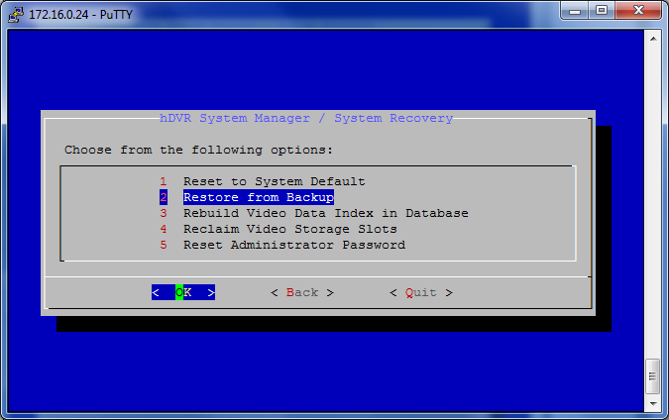
- Select ‘Restore from Backup.’
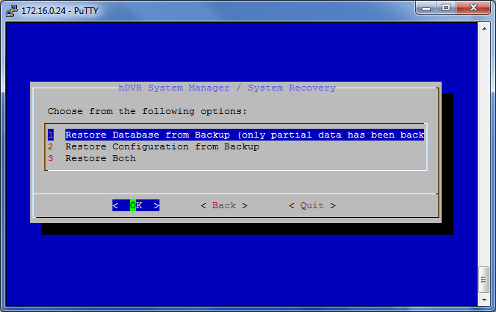
- Select ‘Restore Database from Backup.’
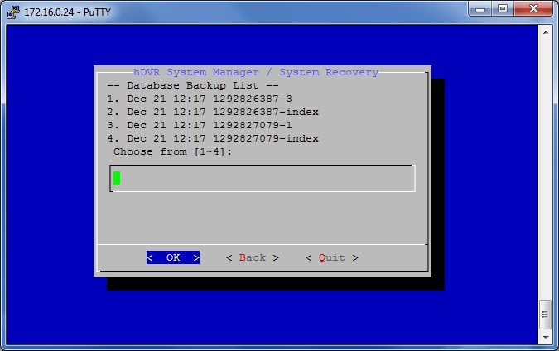
- The system shows a list of database backups. The backups are sorted by the number of the hard drive on which they are saved. Input the number of the target backup and select ‘OK.’
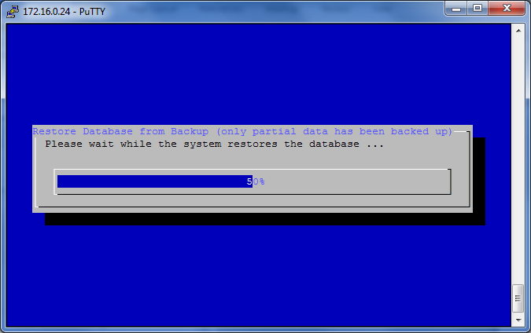
- The message ‘Please remember to start hDVR service manually’ will display when the recovery process is completed. Select ‘Back’ to return to the main menu.
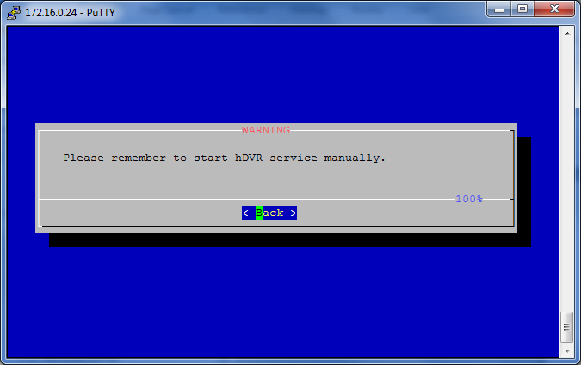
Note: Restart the hDVR to activate the change.

Restore Configuration
To restore the previous hDVR configuration, follow the steps below:
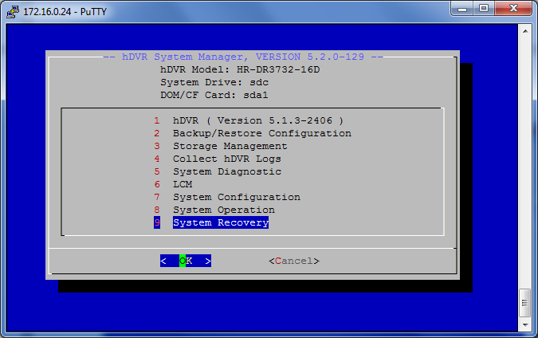
- From the main menu, select ‘System Recovery.’
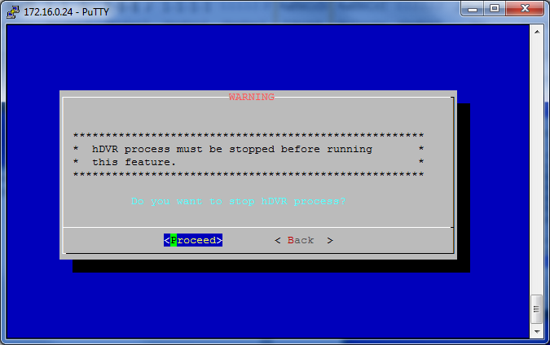
- The system will ask for confirmation to stop the hDVR process.
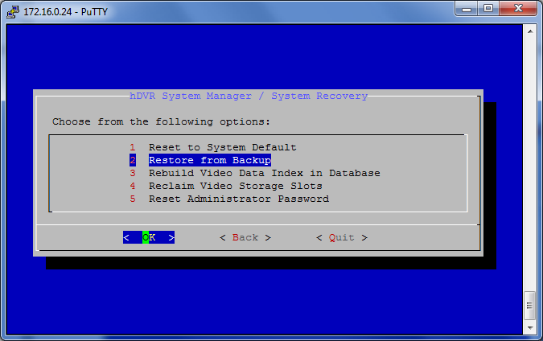
- Select ‘Restore from Backup.’
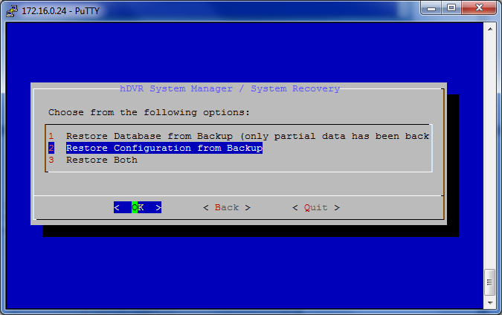
- Select ‘Restore Configuration from Backup.’
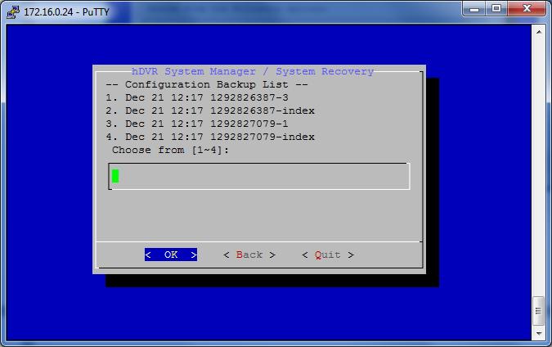
- The system shows a list of configuration backups. The backups are sorted by the number of the hard drive on which they are saved. Input the number of the target backup and select ‘OK.’

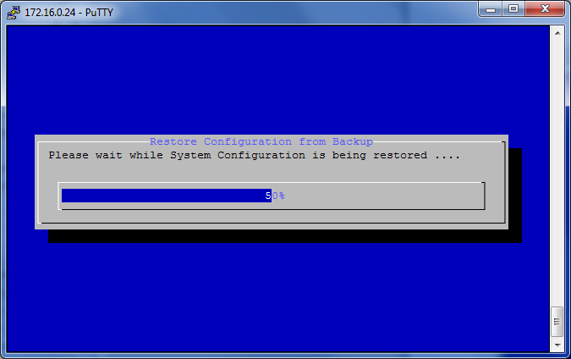
- The message ‘Please remember to start hDVR service manually’ will display when the recovery process is completed. Select ‘Back’ to return to the main menu.
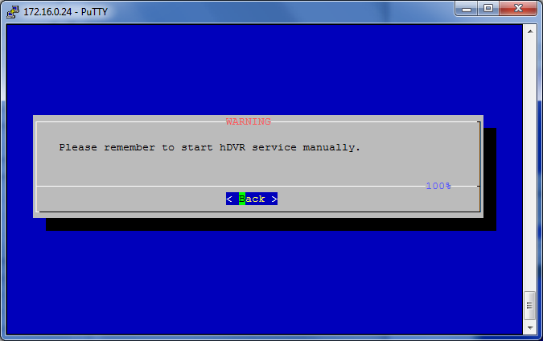

Note: Restart the hDVR to activate the change.

Restore Both Database and Configuration from Backup
To restore both the database and configuration from a backup, follow these steps:
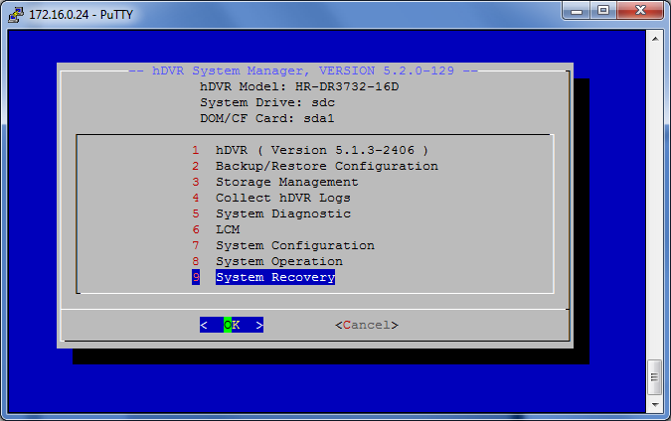
- From the main menu, select ‘System Recovery.’
- The system will ask for confirmation to stop the hDVR process.
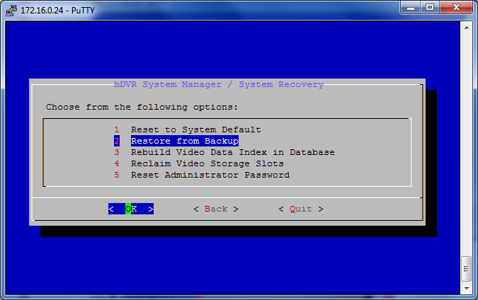
- Select ‘Restore from Backup.’
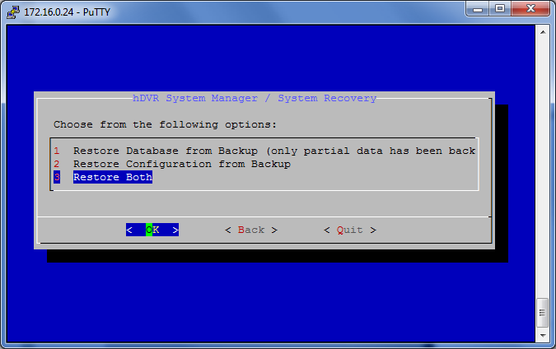
- Select ‘Restore Both.’
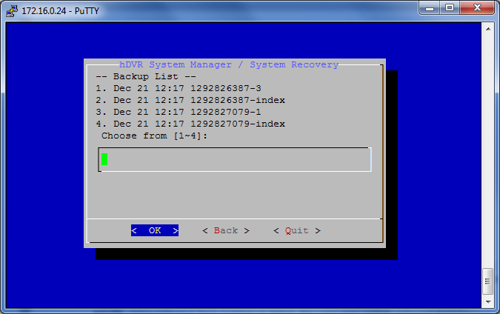
- The system shows a list of database and configuration backups. The backups are sorted by the number of the hard drive on which they are saved. Input the number of the target backup and select ‘OK.’

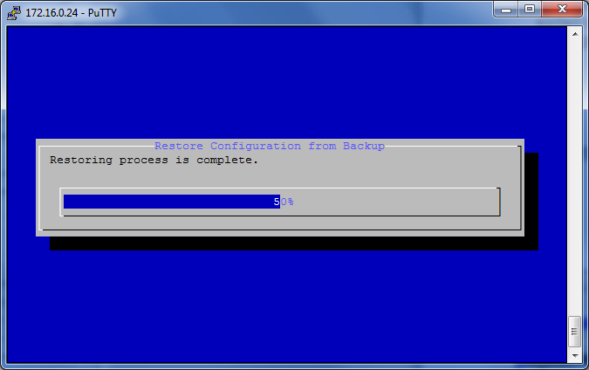
- The system shows a progress bar.
- The message ‘Please remember to start hDVR service manually’ will display when the recovery process is completed. Select ‘Back’ to return to the main menu.

Note: Restart the hDVR to activate the change.

Rebuild Video Data Index in Database
When the AVSlot data on a hard drive does not match the AVSlot table on the system disk, the system will display damaged status. Follow the steps below to rebuild the video data index in the database: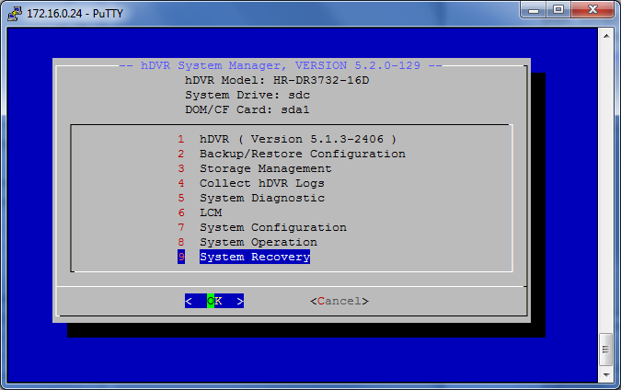
- From the main menu, select ‘System Recovery.’
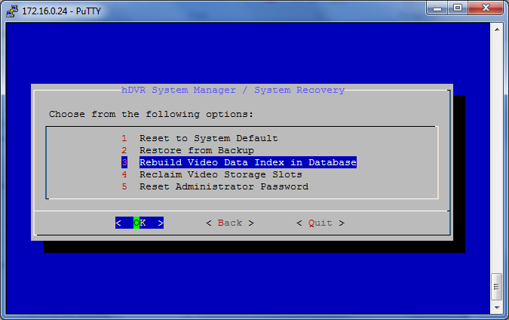
- Select ‘Rebuild Video Data Index in Database.’
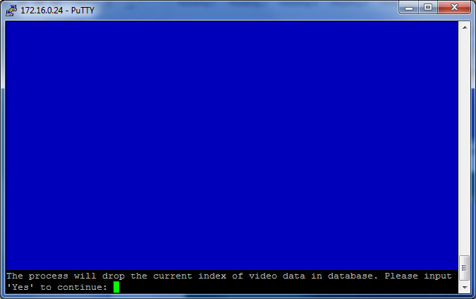
- The system will display a warning. Input Yes and press <Enter> to continue.
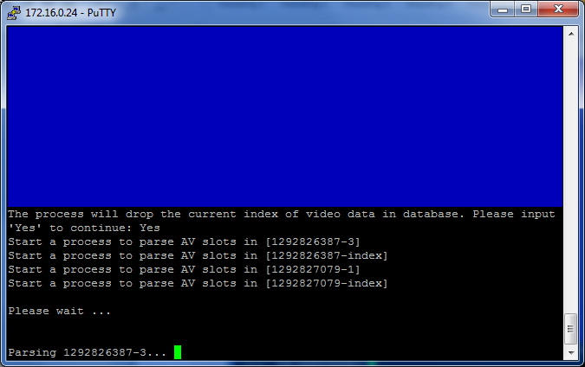
- Upon completion the hDSM will revert to the System Recovery menu.

Note: Restart the hDVR to activate the change.

Reclaim Video Storage Slots
The ‘Reclaim Video Storage Slots’ function will reclaim storage slots that have been marked as ‘bad’ during previous accesses. Follow these steps to reclaim video storage slots:
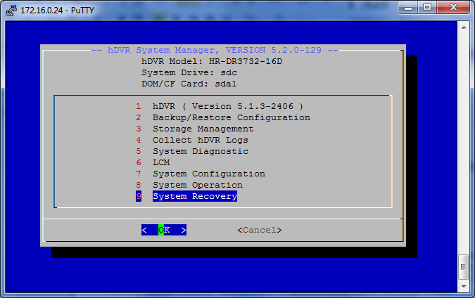
- From the main menu, select ‘System Recovery.’
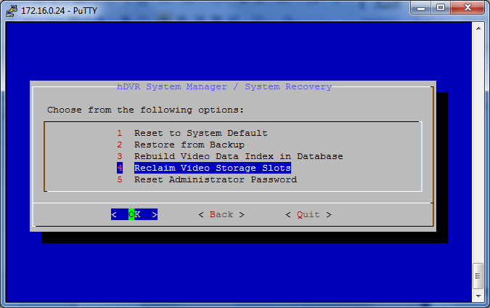
- Select ‘Reclaim Video Storage Slots.’
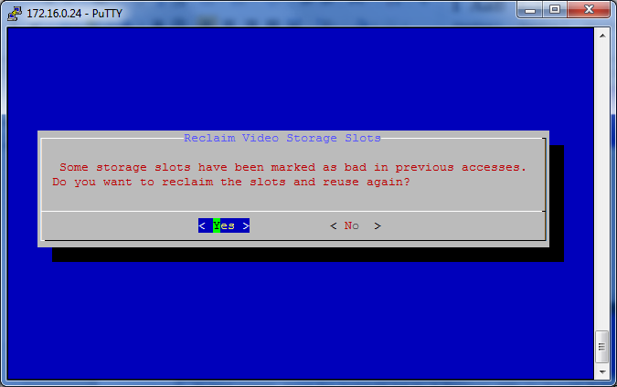
- The system will ask for confirmation before proceeding.

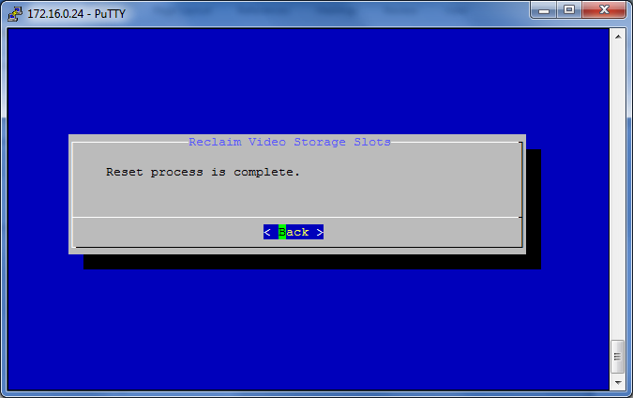
- The system will display a notification upon completing the operation.

Note: Restart the hDVR to activate the change.

Note: Replace the hard drive if the bad blocks increase continuously after reclaiming video storage slots.

Note: If the hDVR is rebooted unexpectedly, the hard drive block currently being written to will be marked as bad. Run the reclaim video storage function to recover bad blocks on the hard drive.

Reset Administrator Password
Follow the steps below to reset the administrator password to its default value:

Note: This function does not apply to the root hDVR password.
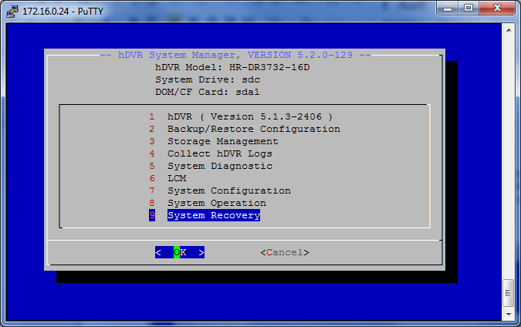
- From the main menu, select ‘System Recovery.’
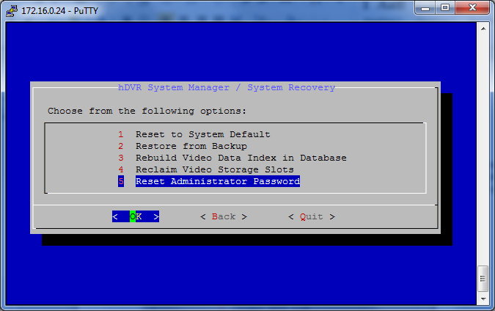
- Select ‘Reset Administrator Password.’
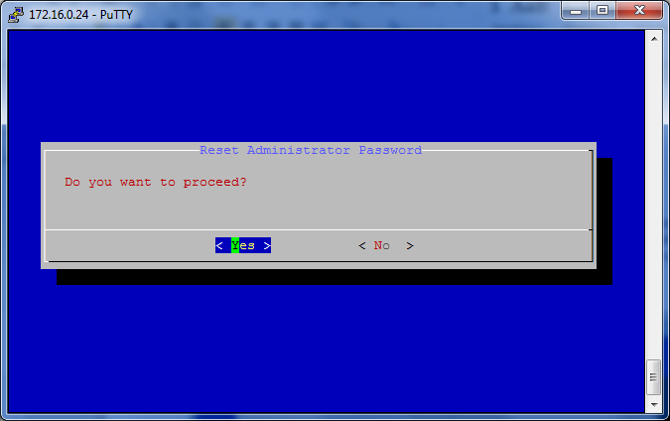
- Select ‘Yes’ to confirm the operation.
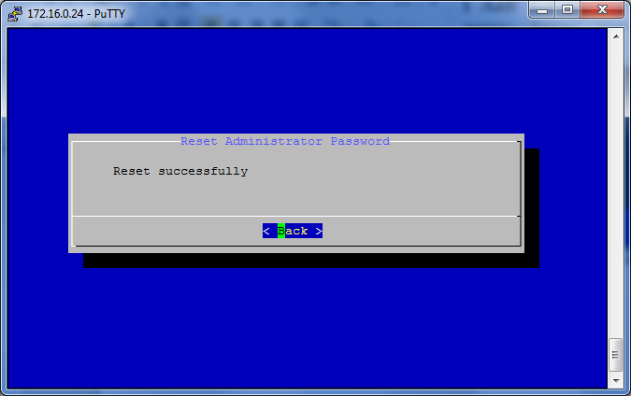
- The system will display a notification upon completing the operation.

Note: After password reset the user will be able to log into the Command Center series application using the default administrator password. The default administrator password is id.

